

PT. SINKO PRIMA ALLOY
Alamat : Jl. Tambak Osowilangun Permai No. 61,
pergudangan osowilangun permai Blok E7-E8,
Surabaya-Indonesia (60191)
Telepon : 031-7482816
Fax. : 031-7482815
Aftersale (WA) : 0821-4281-7085
Email : aftersales@elitech.co.id
sinkoprima@gmail.com
Website : www.elitech.id

SPA-PP/PROD-17. 23 Juli 2024. Rev04

CONTENTS
CONTENTS i
A. OVERVIEW TS-8830 1
B. INTRODUCTION 1
C. STRUCTURE OF THE TS-8830 DENTAL UNIT 3
D. SPECIFICATION TECHNICAL 4
E. FUNCTION KNOB 5
F. INSTALLATION 6
1 Preparation 6
2 Open the packaging box for checking 7
3 Main Frame Installation 7
4 Installation of induction Dental Lights 7
5 Installation of Floor Box or Cover Box 8
6 Piping 8
7 Power Supply Connection 9
8 Handpiece Installation 9
G. DEBUGGING 10
1 High Speed / Low Speed (Turbine) Handpiece 10
2 Three-way syringe 11
3 Salive ejector 12
4 Scaler 12
5 Gargle water 12
6 Rinse the water in the cuspidor/sink 13
7 Water Bottle 14
8 Headrest 14
9 Raise and lower the dental chair 14
10 Backrest settings. 15
11 Setting the normal position in the dental chair 15
12 Settimg at highest/lowest position 16
H. CARE OR MAINTENANCE 16
J. ACTION PREVENTION 19
K. CIRCUIT SCHEMATIC 20
L. SCHEME WATER CHANNELS AND PNEUMATIC CONNECTION 21
M. TROUBLESHOOTING 21

- OVERVIEW TS-8830
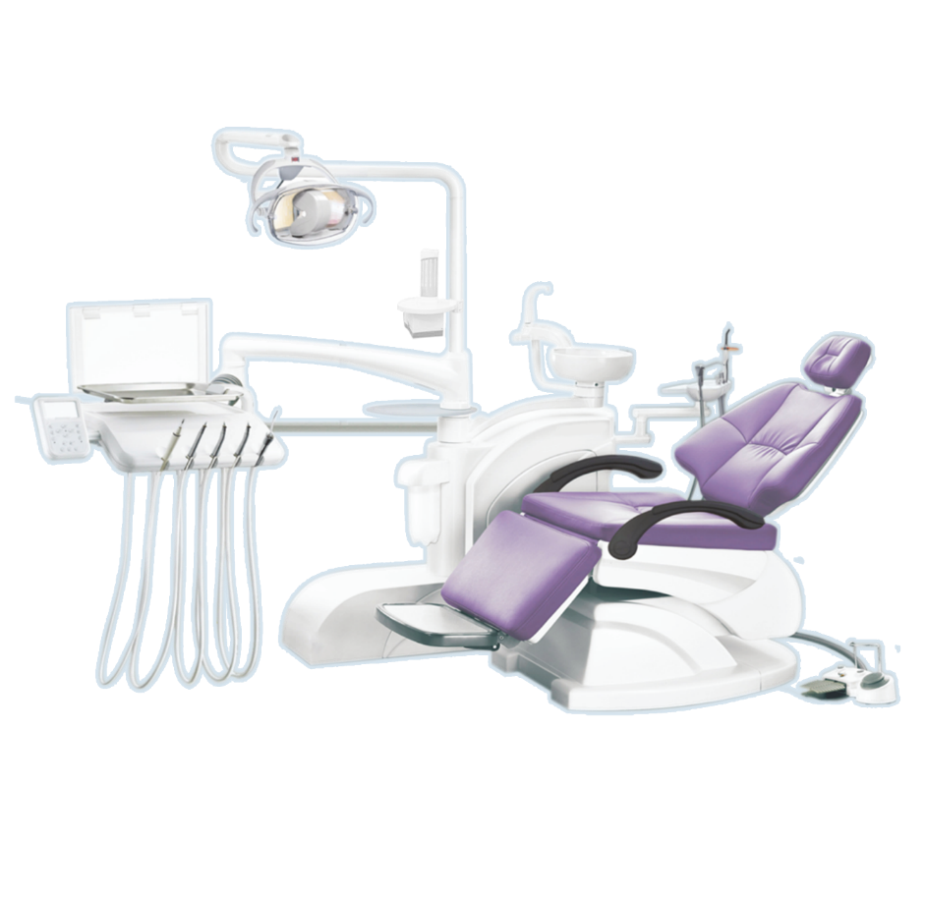
- INTRODUCTION
Thank you for purchasing our product Dental Unit TS-8830. With ABS plastic cover, free from distortion, depigmentation and harmful toxins with fully computerized automatic control; has advantages such as solid structure, good shape, easy operation and high reliability as an ideal upgrade product for modern dental clinics.
The Dental Chair uses a quiet DC motor as a drive system which is integrated with two control points ( table assistant And table Doctor ) and electric foot switch. The design of the control switch is ergonomic , which can easily increase safety and facilitate doctors in working quickly and efficiently.
The backrest is designed with an ergonomic model. The dental unit uses lamp technology that has a long life time , lamps that have cold light, ergonomic ceramic sinks and dental arms with an air-lock system. High/low speed devices use an independent water supply which can extend the service life of high/low speed devices. Compared to 2-holed devices, 4-holed devices have extra exhaust holes. The water heater has an extra suckback-proof design which can protect against infection transmission between patients. And use a three way syringe, 1 for water and dual saliva / suction ejector.
The manufacture of the TS-8830 dental uses fully integrated computerized technology, making the dental unit a unit that has good benefits.
- STRUCTURE OF THE TS-8830 DENTAL UNIT
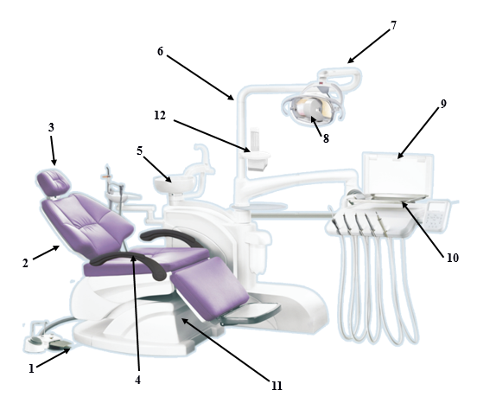
Figure 1 Structure of the Dental Unit
1. Electric Foot Switch | 7. Lamp Arm
2. Backrest | 8. Introduction Dental Lamp
3. Rotatable Headrest | 9. X-Ray Film Viewer
4. Rotatable Armset | 10. Instrument Tray
5. Ceramics cusppidor | 11. Chair Body
6. Lamp Stand | 12. Tissue Box & Cup Holder
- SPECIFICATION TECHNICAL
Type | : TS-8830
Unit Dimensions | : (L)310 X (W)200 X (H)210 cm
Heavy | : ± 150 Kg
Maximum Load | : 130 Kg
Position Chair Mattresshighest | : 74 cm
Position Chair Mattress Lowest | : 55 cm
List Accessories | : 2 Try way Siringe (1 Doctor's Table & 1 Table assistant )
List Accessories | : 2 High speed
List Accessories | : Low Speed
List Accessories | : Scaler
List Accessories | : Blood Suction
List Accessories | : Saliva Ejector
List Accessories | : Light Curing
Power Supplies | : AC 210V – 240V
Frequency | : 50 Hz
Input Power | : 800 VA (Pf = 0.8)
Fuse | : FRI-20 φ5 × 20 5A
Air Pressure Input | : 0.5 ~ 0.8 Mpa Flux ≥50L/min
Water Pressure Input | : 0.2 ~ 0.4 Mpa Flux ≥10L/min
Room Temperature | : 5 ~ 40˚ C Humidity ≤80%
Water Temperature | : 45 ± 5˚ C
Maximum Speed Hig Speed | : > 100,000 Rpm
Maximum Torque | : ≥ 6 g.cm (air pressure: 0.22 Mpa)
Maximum Speed Low Speed | : > 40,000 Rpm
Notes:
Dental TS-8830, blue hose for water lines, Transparent / Yellow hose For channel air
- FUNCTION KNOB
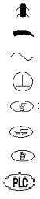 | B Device | 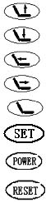 | Dental Chair Up Button
 | It goes down when clockwise and goes up when counterclockwise |  | Dental Chair Down Button
 | air conditioning |  | Reclining Backrest
 | Protected Terminal |  | Vertical Backrest
 | Gargle Button |  | Reset Button
 | Cuspidor/Sink Button |  | Memory Settings
 | Water Heater Button |  | Power Indicator
 | Reset Button |  | Reset Button
- INSTALLATION

1 Preparation
Determine where the unit will be installed according to light settings and availability of treatment, install the machine in a clean, dry, flat and cool place such as the temperature when the machine is working as described in this manual. Make sure the dental chassis has flat and firm contact with the base. Under the box cover, there must be an inlet/outlet for water, gas and an electricity source for the machine with a distance of 140x120mm. Water and air supply hoses must be 8x5 PU pipes. The drain pipe must be 40mm (3/2”) diameter at the connection. The end of the joint of each pipe is 40mm above the floor. The input cable must contain 3 cores (three copper wires) 1mm. For more chart details, see Fig 2.
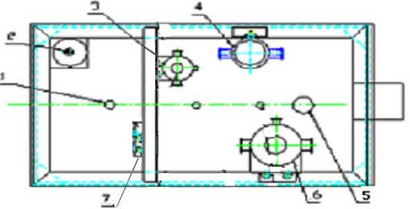
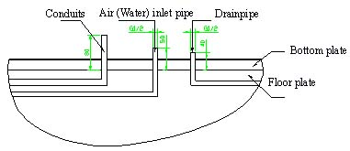
Fig. 2 Floor Box

1. Conduits | = | Pipeline
2. Transformers | = | Transformers
3. Small reducing valve | = | Reducing Valve
4. Water filter | = | Water filter
5. Barometer | = | Barometer
6. Air filter | = | Filter Reducing valve for Air ducts
7. Wire unit | = | Suite Cable

2 Open the packaging box for checking
Open the packaging box to ensure the unit is still intact and check that the accessories and spare parts are still intact and complete as on the packing list. For other questions, contact the distributor and manufacturer PT. Sinko Prima Alloy

3 Main Frame Installation
First, place the dental chair in the right and flat place. And make the unit stable in place. So the use of Foot-Fixing screws is not necessary. But the chassis of the unit must have contact to reduce the risk of accidents.
In the case of the unit rotating and the position of the unit changing due to an uneven floor, this can be overcome by tightening 6 M12 Allen bolts into the 6 M10 screw holes in the dental and making the unit have full contact on the floor. When setting up, make sure the unit has as many contacts as possible on the floor. And ensure the stability of the unit.

4 Installation of induction Dental Lights
Attach the cable from the Lamp Arm to the Lamp Stand and connect the two. After that, connect the two lamp connections on the Lamp Arm to the Dental Cabinet and put the cable into the Column. Then put the Lamp Stand onto the Column and install the Lamp Arm into place (note: don't damage the cable)
Connect the lamp connector cable that enters through the Lamp Arm cover. Insert the Lamp Handle into the hole in the Lamp Arm and lock it with a screw (see picture 3) and cover the screw and cover it with the Lamp Arm cover.
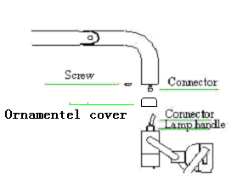
Fig 3 Dental Light Induction

5 Installation of Floor Box or Cover Box
Connect 2 G ½”x φ8 hoses to the water inlet and water outlet. Pay attention to the tightness of the connections when installing and avoid water and air leaks. Open the Floor Box or Cover Box and install the hose horizontally (to facilitate the drain in the machine) rather than installing it higher than the floor. This position must prevent the hose or pipe connecting the cabinet from the floor box or cover box from being pinched, which can occur when the dental chair is raised or lowered.

6 Piping
Before connecting to the unit, the first way is to remove the dirt in the pipe, to extend the service life. Connect the Ф8×1 PU pipe to the water source and air supply. And pay attention to the tightness of the connection. (see Fig.2) . Additionally insert the drainage nozzle connection and connect it to the drain. Pay attention to the tightness.

7 Power Supply Connection
This machine is equipped with a single-phase 3 pin socket. Without a connector, the user cannot turn on the electricity until the unit is connected to a power source.

8 Handpiece Installation
According to the instructions in the manual, connect the handpiece and prevent it from long idling or over-pressure at startup.
- DEBUGGING

1 High Speed / Low Speed (Turbine) Handpiece
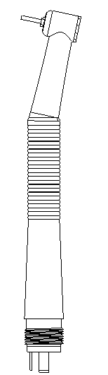
Replace water lines, air lines and circuits. Hydraulic pressure should be 0.2 ~ 0.4 Mpa. Too low hydraulic pressure will result in normal water output and too high hydraulic pressure will affect the connection tension in the entire machine. Filter reducing valve reduces water pressure to 0.55 ~ 0.6 Mpa. For errors, you must adjust the filter reducing valve to control the water pressure in that range. To do this, open the floor box cover or box cover (fig.2) and pull and turn the reducing valve up by 10 mm (fig.4) and turn the handle counterclockwise to go up and clockwise to go down.
Handpiece
Supply water to the handpiece from the water storage bottle directly. The water pressure depends on the air pressure in the water storage bottle, which is controlled from the reducing valve in the floor box or cover box. Open the floor box to check the voltmeter on the reducing valve and make sure it reads 0.2 mPa. For any errors, set the reducing valve above that number. The setting method is the same as setting the reducing valve.
Reducing Valve
Handpiece
Take the turbine handpiece from its holder and step on the foot switch on the left side of the air control setting. Then the handpiece turbine will spray cold water, when the turbine starts working at high speed. Note: at that time, the pressure on the voltmeter shows that the turbine is working (*1). Where it cannot touch the maximum pressure value of the turbine handpiece to avoid damage to the device. To adjust the pressure on the turbine handpiece by controlling the valve under the instrument tray (fig.5), turn it counterclockwise for lower pressure and vice versa. Please arrange carefully and slowly.
Fig.4 Filter Reducing Valve
Fig.4 Filter Reducing Valve
8
This machine uses a four-holed channel on the handpiece with the function of removing remaining water when finished working by pressing the footswitch button in the middle. The water flow in cold water can also be adjusted, by turning the water volume knob under the instrument tray (fig.6). The turbine handpiece is a very precise piece of equipment, read the manual before using.
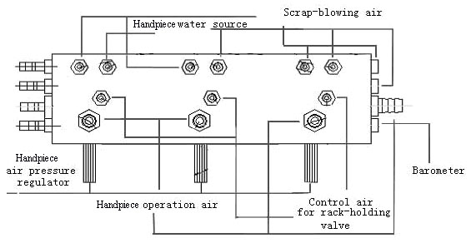
Fig. 5 Main Control Valves
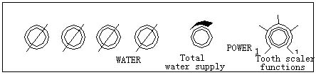
Fig. 6 Control valve for scaling or water supply

2 Three-way syringe
This unit has warm water for the three-way syringe in the instrument tray where warm water is supplied from an automatic water heater. If warm water is needed, simply press the heating button on the control panel. (fig.7) and the water heater will turn on (same sound as pressing any other button except for type-C motors) with an LED light indicator. Which means heating will turn on as the water temperature rises. With the indicator flashing, which means it is in a waiting state for the heating process. This will happen repeatedly to ensure a constant water temperature.

3 Salive ejector
This unit has a saliva ejector that will operate when taken from the tray, weak ejection is realized by suction on the water, therefore it must be connected to a water supply to ensure low water pressure for operation.

4 Scaler
Ultrasonic scaler, is an optional handpiece. If using an ultrasonic scaler, simply take the handpiece from the tray and press the switch on the foot switch to use it. Pay attention, the scaler will only work when there is water, otherwise it will damage the scaler. The water output can be adjusted with the button under the tray (fig.6). The scaler head must be tightened, otherwise it will affect the efficiency of the scaler.
As a sophisticated tool, read the manual before using.

5 Gargle water
To stop turning on the water for gargling, press the button again to turn it off. Like the warm water supply coming out of the heater, press the heater button if you want warm water. The heating performance is the same as a three-way syringe heater. The water output is computerized which the user can adjust manually. Press the "SET" button on the control panel on the instrument tray then the indicator will light up then place the empty glass in the mouth gargle. And press the “Gargling Water” button on the control panel. The machine will fill automatically, press the button again to stop filling. The computer will accumulate the values that have been set.

6 Rinse the water in the cuspidor/sink
- Press the SET button then the indicator will light up.
- Press the rinse button on the cuspidor/sink, with the following timer:
- Press once, water will come out for 30 minutes and the indicator light will come on once
- Press twice, water will come out for 60 minutes and the indicator light will light up twice
- Press three times, the water will come out manually without stopping automatically and the indicator light will light up 3x
- Press four times, water will come out as a test. The indicator light will light up 4x. water will come out for 12 seconds.
- Press the "SET" button again after completing the settings, the light indicator will turn off and the setting process is complete. All memory that has been set will be saved so you can use it by simply pressing a button on the control panel
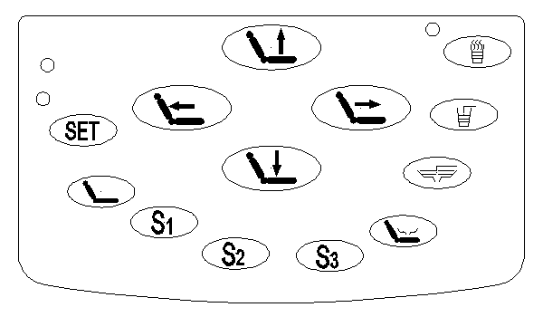
Fig. 7 Control Panel
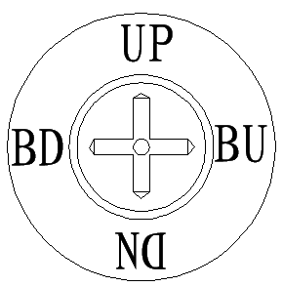
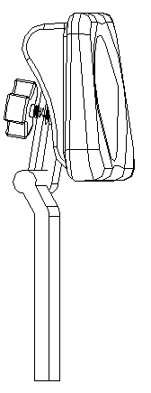
Fig. 8 Headrest Fig.9 Foot Switch

7 Water Bottle
Water for the handpiece is taken directly from the bottle. Therefore the bottle must be supplied with medical distilled water in a timely manner, with the filling water described as follows: turn off the air switch in the control box. After the compressed air in the bottle has run out, remove the bottle by turning it counterclockwise. Fill the bottle with water then install the bottle counterclockwise until it is completely tight. After that, turn on the air switch. The water filling process is complete.

8 Headrest
The headrest can be adjusted into 2 functions, one for adults and one for children. The angle and height of the Head holder at that point can be adjusted (Fig.8). If you want to adjust the tilt of the Head Holder, first hold the head holder, simply pull it out or press down on the head holder to position it directly and make the head holder in a comfortable position. CAUTION: after setting the head holder, the lock must be locked again to avoid accidents.

9 Raise and lower the dental chair
The dental unit has 3 dental chair movement controls, the chair can be controlled from 2 control panels and a foot switch.
To raise the dental chair, simply press the chair button with the up arrow on the control panel or by moving the analog lever up on the foot switch. Release the button and the process of raising the chair will stop.
The same method is used to lower the dental chair by pressing the chair button with the down arrow or by moving the analog lever down on the foot switch.
Remark: make sure there are no objects within the distance the dental chair rises or falls, to avoid accidents.

10 Backrest settings.
The settings are the same as lowering and raising the dental chair by pressing a button on the control panel or foot switch.
To straighten up, press the seat button with the arrow to the right on the control panel or by sliding the analogue to the right on the foot switch.
To recline, press the chair button with the arrow to the left on the control panel or by sliding the analog to the left on the foot switch.
Remark: Make sure there are no objects within the distance of the dental chair in the shifting and straightening positions, to avoid accidents.
Remark: Pressure indicator is on the table The doctor has a deviation from the pressure in the high speed/low speed handpiece connected to the pressure loss in the connection pipe. The pressure indicator on the tray is very useful for service and service life.

11 Setting the normal position in the dental chair
- Press the “SET” button for 5 seconds, then the indicator light will light up, then it will enter the setting position.
- Arrange the dental chair in a comfortable position.
- Press the preset button (such as S1 button).
- Press the “SET” button again to save the settings, the light indicator will turn off and the setting process is complete. In future use, simply press the preset button (such as the S2 button) and the electric chair will move according to the settings (if you want to change the position of the chair while the chair is in motion, press the button again to stop the process).
- Settimg at highest/lowest position
- Press the “SET” button for 30 seconds, the indicator will flash on and off while buzzing at the same time to enter setting mode.
- b. Press the "UP" "UPRIGHT" button to move the chair to the extreme position requiring manual movement of the chair, press the "SET" button to save the extreme position of "UP" "UPRIGHT"
Press the "DOWN" "DOWN" button to the extreme position, press the "SET" button again, then the setting indicator light will turn off and the setting is complete.
- CARE OR MAINTENANCE
- Handpiece Cleaning and Lubrication
Please read the manual for the handpiece
- Water Filter
The water filter is installed in the water supply channel in the floor box or cover box. To inhibit water impurities (Fig.10), so as to ensure smooth operation of the unit. After a while the filter may be blocked by dirt, which must be cleaned or replaced to normalize the water flow.
Clean or replace periodically after:
- Used for more than 1 year
- Reduced pressure, 0.1 Mpa
- Filter is contaminated
- Contaminated water output
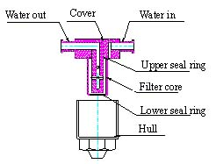

Fig. 10 Filter Air
Cleaning or filter replacement procedure: open the Cover Box and take out the water filter, remove the hull on the water filter by turning counterclockwise, then take out the seal and filter core. After cleaning or replacement, reassemble the water filter upside down and pay attention to the tightness of the connections.
- Filter Reducing Valve
To ensure dry and stable air pressure, the air filter on the reducing valve must be installed at the inlet on the floor box or cover box, the air pressure does not exceed the proper value and also removes dirt and moisture. The water is collected in the filter cup and then thrown away after it has been collected.
Draining water from the reducing valve must be done at:
- Has been used for 1 week
- The water in the filter cup reaches ¾ of the volume
- Color change on the filter cup (no longer clear)
Procedure for draining water on the reducing valve: remove the cover box, turn the nut under the filter clockwise by hand, then the water will flow out. After all the water has been removed, close it again with the screw counterclockwise. To keep it clean, place a water-absorbing cloth (such as a rag/majun)
- Panoramic X-Ray Film Viewer
The X-film display screen is used to observe the X-film, when damage occurs after it has not been serviced for a long time and simply replace it as necessary.
Replacement steps:
a. Remove the power source
b. Remove the back cover and you will find a U-Shape energy saving lamp (5V 7W) inside, check the tightness of the lamp to see if it is loose or damaged, repair or replace it then assemble it as before
Note: The lamp uses 220V high voltage electricity, make sure to remove the power source first.
5. Valve on Tray
Insert the core in the control valve into the tray box using a screw, with the interval between the core valve and detector being adjustable. Under normal conditions, place the handpiece or salive ejector on the tray, and press the valve. Make the valve core move to the left and block the air channel with four rubber rings measuring 1.2. If the air flow does not stop even though the handpiece is installed on the tray, there is a leak in the system. Just loosen the locking screw and slide the clamp to the correct position, check whether the valve can cut off the air channel or not, if that doesn't work, disassemble the valve again on the tray, maybe there is damage to the O ring.
Detail steps:
- Cut off air source
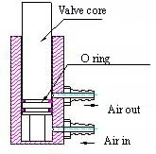
- Loosen the locking screw and remove the tray, take out the valve core then you can find the rubber ring. (fig.11)

Fig. II Valve in tray
- ACTION PREVENTION
- When operating a dental chair, make sure there is nothing blocking the movement of the dental chair.
- Remove any remaining water from the filter at any time.
- Clean or replace the filter core regularly
- Replace the filter cup when the water output is weak
- When controlling the movement of the chair up/down, the button must be pressed until it reaches the desired position
- After adjusting the position of the head holder, lock the position.
- Disconnect the power source when changing electrical components
- Disconnect the power source when carrying out maintenance and cleaning on the unit.
- Optional parts such as scalers, curring lights must be products that pass CE
- Environment for transportation or storage
- Room temperature -40 ~ +70˚ C
- Humidity 10% ~ 100%, including condensation
- Air pressure 500~1060 hPa
The unit must be protected from rain when moved and protected from impact by sharp objects.
The packaged unit must be stored indoors where humidity is less than 80% without corrosive gases and good air circulation.
- Disposal of waste water and other things must meet targets and regulations.
- Unit maintenance must be carried out by a professional technician from the manufacturer, the unit may be damaged if the user tries to open and repair it himself.
- CIRCUIT SCHEMATIC
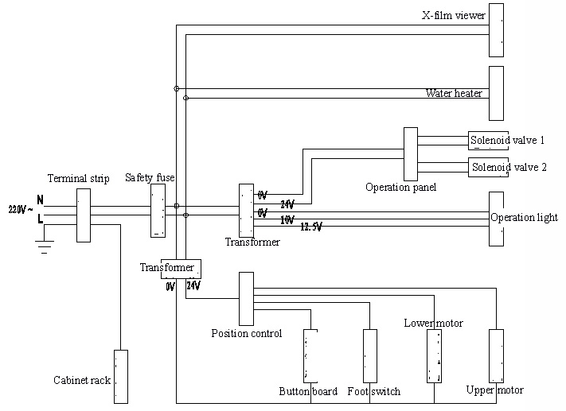
- SCHEME WATER CHANNELS AND PNEUMATIC CONNECTION
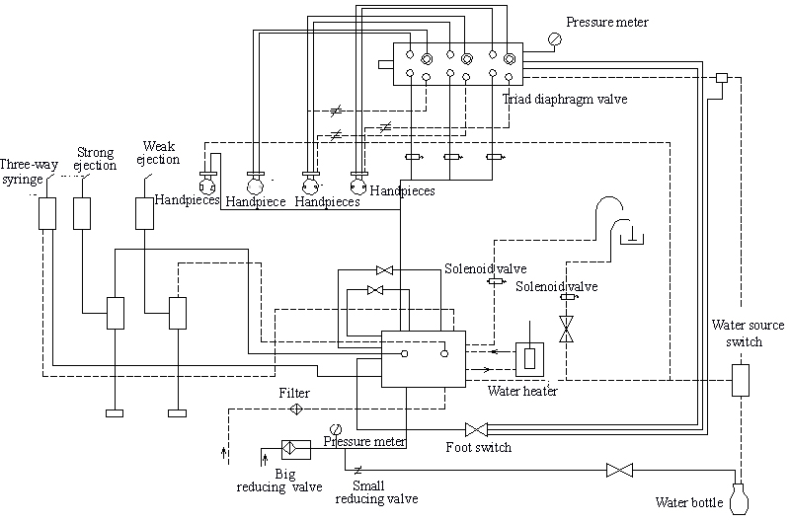
- TROUBLESHOOTING
PART | DAMAGE | REASON
Main Unit | ON/OFF button is off  (unit completely dead ) | Travo High Voltage is damaged
Main Unit | ON/OFF button is off  (unit completely dead ) | Connection Power cable disconnected
Main Unit | ON/OFF button is off  (unit completely dead ) | Fuse 8A 220V broken
Main Unit | ON/OFF Button On  (unit completely dead ) | ON/OFF button socket is loose
Table Doctor | Handpieces No emit Air | Hose Air pinched
Table Doctor | Handpieces No emit Air | Failure valve Air
Table Doctor | Handpieces No emit Air | Arrangement Table doctor
Table Doctor | Handpieces No emit Air | Central air does not enter
Table Doctor | Handpieces dripping water or No there is water | water hose is stuck
Table Doctor | Handpieces dripping water or No there is water | Failure water valve
Table Doctor | Handpieces dripping water or No there is water | Arrangement Table doctor
Table Doctor | Handpieces dripping water or No there is water | Central water does not enter
Table Doctor | Problem with Control Panel | Connection socket problematic
Table Doctor | Problem with Control Panel | The control panel is damaged
Table Doctor | Handpieces Damaged | The rupture hose
Table Doctor | Handpieces Damaged | Valve rack loose
Table Doctor | Handpieces Damaged | Failure tool handheld
Table Doctor | Handpieces Damaged | Damaged Mainboard
Cuspidor and center support | No water heater Work | The heater is broken
Cuspidor and center support | No water heater Work | Voltage No enter
Cuspidor and center support | Saliva​ or glass gargle leaking or No there is water | Failure solenoid valve
Cuspidor and center support | Saliva​ or glass gargle leaking or No there is water | Mainboard damage
Cuspidor and center support | Saliva​ or glass gargle leaking or No there is water | Connection Cable problematic
Cuspidor and center support | Cuspidor water contains air | Valve problem
Cuspidor and center support | No there is water | Solenoid valve problem
Cuspidor and center support | No there is water | Failure board circuit
Cuspidor and center support | No there is water | Problem with water connection
Cuspidor and center support | No time settings​ enter sense | Incorrect settings​
Chair tooth | Chair base No Can move | Mainboard damage
Chair tooth | Chair base No Can move | Damage hydraulic
Chair tooth | Chair base No Can move | Cable Port Connection
Chair tooth | Chair base No Can move | Sensor damaged
Chair tooth | Backrest hand damaged | Too strong usage
Light Operation | No Can Work | Bulb Damaged
Light Operation | No Can Work | Fuse 8A 12.5 V Disconnected
Light Operation | No Can Work | Connection cable problematic
Assistant Desk | Problem with Control Panel | Connection socket problematic
Assistant Desk | Problem with Control Panel | The control panel is damaged
Assistant Desk | Low Suction | Central water does not enter
Assistant Desk | Low Suction | Low Suction Damage
Assistant Desk | High Suction | Central air does not come in
Assistant Desk | High Suction | Damage valve positioning
Assistant Desk | Curing Light Off | Cable separated
Assistant Desk | Curing Light Off | Connection Socket cable
Foot Switches | Handpieces Work in a way automatic moment lifted | Foot switch is broken

DENTAL UNIT
TS-8830

MANUAL BOOK




